

Wait Zar user's guide version 1.5+ β

Table of Contents

1. Introduction p. 2
2. Requirements p. 2
3. Basic Usage p. 2
3.1 Switching from Myanmar to English p. 3
3.2 Typing Words in Myanmar p. 3
3.3 Special Keys & Punctuation p. 4
3.4 System Tray Icon p. 4
4. Finding a Word p.
4.1 The WaitZar Romanisation p.
4.1.1 Default Romanisation p.
4.1.2 Special Romanisations p.
4.1.3 Shortcuts p.
4.2 Dictionary Lookup p.
5. Advanced Usage p. 5
5.1 Changing the Hotkey p. 5
5.2 Configuration Options p. 6
5.3 Changing the Font p. 8
5.4 Adding Your Own Words p. 9
5.5 Running Wait Zar from a USB Drive with PStart p. 10
6. Troubleshooting FAQ p. 12
6.1 Known Font Issues p. 13
Appendix A: License p. 14
Appendix B: How It Works p.
1. Introduction

Welcome to Wait Zar, a syllable-level romanized input system for the Burmese language. Thanks for downloading this software; please go to:
http://code.google.com/p/waitzar/
...for the latest version of Wait Zar, or if you'd like to join the project. If you’d like to receive emails whenever Wait Zar is updated, please sign up to our mailing list:
http://groups.google.com/group/waitzar
Wait Zar is a community project. It is open-source, and free. (This user’s guide was typed using Wait Zar in Microsoft Word.)

2. Requirements

Wait Zar is tested on Windows 2000, Windows XP, and Windows Vista. It should work on these operating systems without any problems. If you are running another configuration (such as Windows Server 2003) and you experience an error, please post a bug report and we will look into it:
http://code.google.com/p/waitzar/issues/entry
You don't need anything else to run Wait Zar. It is designed to be usable from systems you don't have control over, like Internet Cafe or Library computers. You don't even need any Myanmar fonts; you will be able to see the words as you type them. However, if you can install fonts, you should install whichever ones you plan on using. Currently supported fonts are:
- Zawgyi-One
- Win Innwa
- Padauk (OT)
- Parabaik
- Myanmar 3
You should install the Myanmar3 font in order to view this document properly:
http://www.myanmarnlp.net.mm/downloads/Myanmar3_Unicode.zip

3. Basic Usage

This section will describe how to use Wait Zar. After reading this, you will be able to type emails to your friends in Myanmar. To learn everything else, read the sections “Finding a Word” and “Advanced Usage”. If you really want to know everything, read the appendix “How it Works”.
To get started, download the latest version of Wait Zar and double-click “WaitZar.exe”. (You don't have to unzip it.) A blue icon with a white “!” will appear on your status bar, wait for it to change into the letters “ENG” --at this point, Wait Zar is ready to use!

3.1 Switching from Myanmar to English

Initially, Wait Zar will start in “English” mode. Your computer will work just like before, except that pressing the “Ctrl” and “Shift” keys at the same time will switch you to “Myanmar” mode. You can tell when this happens because the “ENG” icon will change to “မြ”. Hit “Ctrl” and “Shift” again to switch back to English.

3.2 Typing Words in Myanmar

Typing a word is accomplished by typing how that word sounds, and by following some simple rules (see: “Finding a Word” for more details). For most words, you can easily guess what you need to type. For example, to type “ko”, just type “k” then “o”. You'll see:
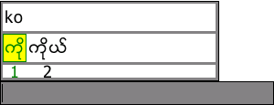
You can drag this window to a better location if you want. Pressing “space” or “enter” will choose the word in green. You can press “left” or “right” to change which word is selected. Pressing the number below a word is a shortcut to choosing that word (e.g., pressing “2” will type “ကိုယ်”). Pressing “escape” will cancel the current word.
After hitting “space”, “enter”, or a number key, you’ll notice that the “sentence window” is still visible:
The sentence window gathers words you’ve typed and permits very simple editing of phrases prior to actually typing them. It also tries to predict which Burmese word you want when you type, e.g., “san” —there are six possibilities! It does this by looking at the previous three words you’ve typed. This is useful, because if Wait Zar guesses correctly (and puts the word in place “1”), you only have to type “space” —no arrow or number keys are required.
Whenever only the sentence window is visible, the following controls apply:
- Pressing left/right will move the cursor (black bar) in the sentence window. The cursor is a “smart cursor”; it will move one word (not letter) each time you press left/right.
- Pressing a letter key will open the main window, and allow you to type another word. This word will appear at the current cursor position.
- Pressing “backspace” or “delete” will remove the word before or after the cursor, respectively. This allows you to fix minor problems in your sentence before committing it.
- Pressing a number key (0-9) will type the burmese numeral (၀-၉) into the sentence window. This feature can be disabled in confix.txt.
- Pressing “Enter” will “commit” the sentence —transfer it to the current active program (e.g., Microsoft Word).
- Pressing “space” will do the same thing, if the cursor is at the end of the sentence. If not, “space” will do the same thing as the “right” arrow key.
- Pressing “,” or “.” will “commit” the sentence, and then type “၊” or “။”.

3.3 Special Keys & Punctuation

Pressing “,” or “.” at any time the language is set to Myanmar will type half or full stop (၊ or ။). If the sentence window is visible, the current sentence will also be committed.
Pressing a number key (0-9) will type the burmese numeral (၀-၉).

3.4 System Tray Icon

Wait Zar will load an icon into your system tray. It will appear as either “ENG” or “မြ”, depending on the language you are typing in. If you right-click on this, you will see several options:
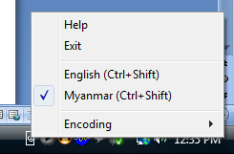
Help — Show basic information about the software.
Exit — Close Wait Zar. Removes all hotkeys from the system. If WaitZar.exe causes your system to slow down or behave strangely, choose this option to stop the program.
English — Change text mode to English. Same effect as pressing “Ctrl+Shift”
Myanmar — Change text mode to Myanmar. Same effect as pressing “Ctrl+Shift”
Encoding — Changes the character encoding of text output by Wait Zar. Set to “Unicode 5.1” by default; you can change this to type text in “Win Innwa” or “Zawgyi-One” as well.

5. Advanced Usage

Wait Zar can be customized to suit your needs. For example, many programmers use “Ctrl+Shift” to select rows of text. They may want to change the language hotkey to “Alt+Shift” —but anyone typing in Chinese will prefer to change it to something else (“Ctrl+Space” maybe). A great deal of configuation options will be available to Wait Zar users. This section details some of them.
In order to apply any of these custom configurations, you must unzip WaitZar.exe into a directory. You cannot just run it from within the zip file. You should also unzip config.txt and mywords.txt, although this is not strictly necessary.

5.1 Changing the Hotkey

The hotkey is just another option, but changing it is the most common request we get. To do this, go to the directory you unzipped WaitZar.exe into. Look for the file “config.txt”. If it doesn’t exist, create it, open it in Notepad (not Wordpad) and add the line:
hotkey = ^m
This will set the hotkey to control m. If config.txt does exist, open it and look for the line:
hotkey = ^+
…and change it to
hotkey = ^m
…this will change the hotkey. The “^” symbol is a “modifier” and the “m” is the “letter” to trigger the hotkey. Wait Zar will always use the last character as the “letter” and all other letters as modifiers. So, if you type:
hotkey = ^^
…then, presumably, one would have to hold “Ctrl” and press “Ctrl” to trigger Burmese. (This will probably just set the hotkey to “Ctrl”… it’s kind of an odd hotkey, really.) The following modifiers are allowed:
^ is for Ctrl
! is for Alt
+ is for Shift
Any character is allowed for a letter, and any modifier can also be a letter. In addition, some “untypable” letters are allowed:
_ is for Space
Please note that, due to the nature of hotkeys under Windows, you should use lower case letters whenever possible. If you set:
hotkey = ^M
…then the hotkey will actually be set to “Ctrl+Shift+m”, because you need to hold down the shift key to type a capital M.
Note: We highly recommend that you don’t use shift+letter (or just letter) for the language hotkey, as this will conflict with that key being used to type Burmese, and you will get an error message upon switching to Myanmar.
If you aren’t sure what the current hotkey is, simply right-click on the system tray icon:
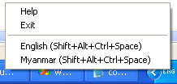

5.2 Configuration Options

To configure Wait Zar, you should edit the file “config.txt”. This file should be present in the same directory as WaitZar.exe; if you don’t have it, you can create it yourself, or just unzip it from the Wait Zar download for the current release.
The config file consists of lines structured as:
name = value
…where “name” is a single word composed of english letters, and “value” can be any number of things, depending on name. The following table lists all configurable options available at the moment. If your config.txt file does not contain a certain option, its default value will be used. If you mis-type a name, it will simply be skipped.
Please note that all names are case sensitive. If you type “Hotkey = ^m”, the system will not recognize that you entered a valid option.
Name | Value | Meaning | Default Value
hotkey | [modifier] letter, where modifier is:  ^ for Ctrl  ! for Alt  + for Shift  …and letter is any of these, or:  _ for Space  …or any letter. | Set the “switch language” hotkey. Use this if the default hotkey conflicts with some other task on your system. Example:  hotkey = ^m  …sets the hotkey to Ctrl+m | ^+
mywordswarning | Either of the following:  yes  no | User-defined words are fully-tested, but you may choose to leave this to “yes” to show a warning if a custom dictionary is used. | no
powertyping | Either of the following:  yes  no | If no, “space” will type each word directly, bypassing the sentence window. We highly recommend setting this to yes. | yes
lockwindows | Either of the following:  yes  no | If no, the sentence window can be disconnected from the main window. Only applies if powertyping is yes. | yes
burmesenumerals | Either of the following:  yes  no | If yes, then 0-9 will type Burmese ၀-၉. | yes
defaultencoding | Either of the following:  unicode  zawgyi  wininnwa  Also:  padauk  parabaik  myanmar3  …mean the same as “unicode”. | Sets which encoding Wait Zar will use when it first loads. Set it to zawgyi or wininnwa if you use these fonts, and leave it as “Unicode” otherwise. | unicode

5.3 Changing the Font

Most new fonts will work with Wait Zar; Unicode 5.1 was a huge improvement to the Myanmar language in this regard. However, two older fonts are used widely in Myanmar publications and blogs, and are also supported by Wait Zar for legacy reasons.
While Wait Zar is running, right-click on the tray icon and choose “Encoding” to see the following:
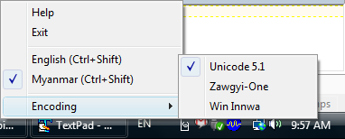
Click on Zawgyi-One or Win Innwa to change the output font. Now you can type in that font as well! To easily tell which language you are typing in, look on the right-hand side of the sentence window. “ZG” is for Zawgyi-One, “WI” is for Win Innwa, and “UNI” is for Unicode output:
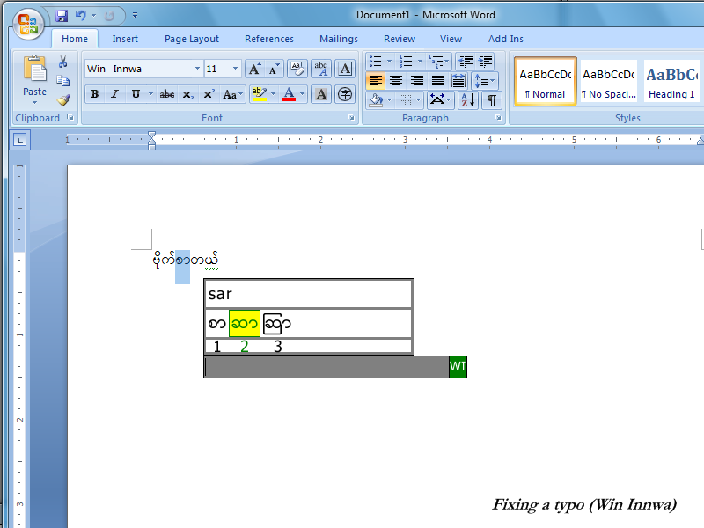
NOTE: You will still have to change the font in Microsoft Word. Also, Wait Zar will always display text internally using the Zawgyi-One font. The “WI” icon notifies you that you are typing in Win-Innwa.

5.4 Adding Your Own Words

To enter your own words, you should edit the file “mywords.txt”. This file should be present in the same directory as WaitZar.exe; if you don’t have it, you can create it yourself, or just unzip it from the Wait Zar download for the current release.
NOTE: If you create this file yourself, make sure you save it in the UTF-8 encoding.
NOTE: When editing this file, do not use Wordpad. You should use Notepad, because Notepad will preserve the encoding. If you use Wordpad, it will change all your Burmese letters to “????”
NOTE: You must enter words using the Zawgyi-One encoding scheme. This will probably be changed in future versions of Wait Zar, so please be patient if the converted output is not correct…
The file mywords.txt consists of pairs of the following:
myanmar = roman
…where “myanmar” is a word in Burmese, and “roman” is its romanization. Note that “roman” should consist of all lowercase letters. Also note that “myanmar” should be written using the Zawgyi-One font. (We will change this later to be more universal.) The best way I’ve found to do this is to type the “myanmar” word in Microsoft Word, then copy-paste it into Notepad. You’ll see it as boxes, but it’ll work correctly.
For example, if you want to enter the word “အ” as “a” instead of “ah”, you can add the line:
အ = a
You can also enter shortcuts. For example, to type “မဂၤလာပါ”, you currently have to type “minga” “lar” “par”. Perhaps you may want to add a new entry:
မင်္ဂလာပါ = mingalarpar
…or, you could even do:
မင်္ဂလာပါ = hello
…if you want to. Note that only letters which fit in the range [a-z\u1000-\u109F] (e.g., Burmese and English alphabets) are currently supported, for reasons of security. Please start a discussion in the forum if you’d like to see other blocks enabled; for now, though, there’s no purpose to this.
NOTE: If you receive an error that says you have “Too many custom words!” (or “nexi” or “prefixes”) then this means you should remove some entries from mywords.txt. There’s almost no reason to have this many custom words, however.
If you find Burmese words that aren’t in Wait Zar, please report them at: http://code.google.com/p/waitzar/issues/list; we’ll add them to the default model for the next release. Thanks!

5.5 Running Wait Zar from a USB Drive with PStart

If you copy Wait Zar to a USB drive, it will work just like normal! Take Wait Zar on the go! However, if you want a really good setup, consider using PStart. Here’s how:
- Download PStart (the normal one, not U-3) from: http://www.pegtop.de/download.php?file=start
- Make sure your USB drive is plugged in, and run the PStart setup file. When you get to the “Setup Type”, choose “Portable Setup”, and select your USB drive’s letter.
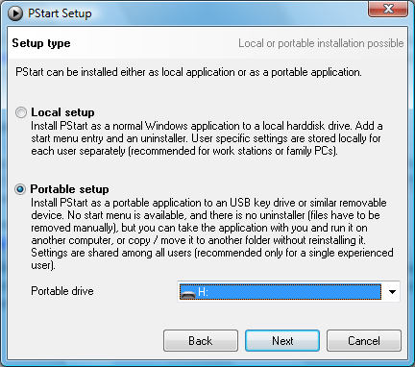
- Now, browse to your USB drive. Make a folder called “waitzar”, and extract the Wait Zar files there. Here’s a snapshot of my USB drive (with some extra folders & files)
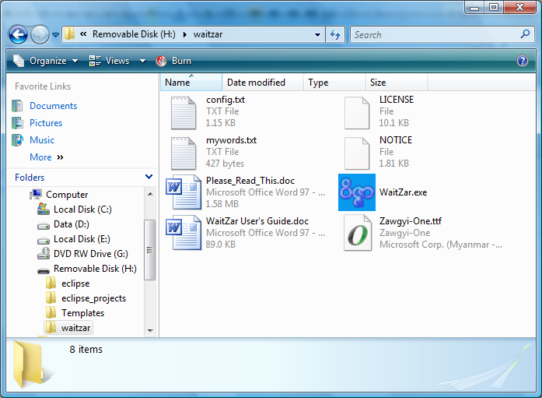
- Now, go to the root folder of your USB drive and click “PStart.exe”. When the PStart window shows, click “Edit” then “Add File”. Browse to the “waitzar” folder we created in step 3, and double-click “WaitZar.exe”. A new window will pop up… click “Ok”. Now, close the PStart window.
- As long as PStart is running, you can click on its icon in the system tray and choose “WaitZar” to launch WaitZar. You can add many other programs to PStart, and get a fully-functional mini Start Menu on any computer you connect your USB drive to!
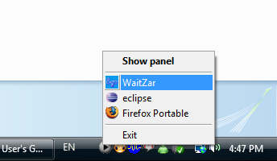

6. Troubleshooting FAQ

Here are some problems our users have run into and their solutions:
Q: When I type in Google Talk, all I see are boxes.
A: Make sure you set the font for Google Talk itself. Click on “Settings” and go to “Choose Font”. If this still doesn’t fix things, make sure you are typing in English (with a US keyboard layout). For example, one user reported problems using WZ while the language was set to Chinese. Switching back to English solved the problem.
Q: I typed a word, and now I can’t delete part of it.
A: This is a common occurrence if you type a word with asat “—္” and then hit “backspace. Sometimes, the asat is after the cursor, although it appears before it. Try hitting the right arrow key, and then backspace. This is an issue with all Burmese fonts in programs that do not fully support Burmese text.
Q: Help! Wait Zar doesn’t work with Open Office!
A: For some reason, Open Office under windows neglects to detect Burmese code points —for some users, it switches to “Tahoma” even if you select Zawgyi-One. The big problem with this is that it will make all Burmese characters invisible, and of zero length! To fix this, after typing hit “Ctrl+A” to select everything and change the font to Zawgyi-One. After this, you should be able to type using Wait Zar without switching the font.
Q: Help! I can’t use Wait Zar during a webcam conversation on MSN.
A: Wait Zar is known to slow down dramatically on a heavily-loaded system —particularly one running a webcam chat. We are looking into this problem. Try dragging the Wait Zar window so that it’s not over the MSN window; this might help reduce repaint conflicts.
Q: (Some word) won’t look correct in Win Innwa or Unicode…
A: Each word was hand-checked for errors. Please see section 6.1 for known errors. Also, it’s important to remember that Myanmar’s Unicode encoding has been fluctuating for several years. Make sure you have the latest font from the developer’s web site. Finally, if you enter your own words, there is a small possibility that they will not convert correctly. Please post a bug report if this happens to: http://code.google.com/p/waitzar/issues/entry

6.1 Known Font Issues

This section requires the Zawgyi-One font to render properly.

Unicode 5.1 is very new, and there are a few glitches in fonts which support the latest standard. When possible, Wait Zar will re-organize the letters in a word to hide these errors. However, this is not always possible. Please be aware of these errors. If you are a font developer, we’d love to hear from you —give us an email and we’ll offer whatever suggestions we can.
Sequence (Zawgyi-One) | Encoding (Unicode 5.1) | Problem | Solved?
ကၤ | \u1004\u103A\u1039  \u1000 | Padauk OT seems to have trouble recognizing kinzi. | Requires font modification.
အက်ႌ | \u1021\u1004\u103A  \u1039\u1000\u103B  \u102E | Similar problem to above, with Padauk OT. | Requires font modification.
သၪၨာ | \u101E\u1009\u1039  \u1007\u102C | Padauk OT extends \u1009 too far; it is far too messy. | Requires font modification.
ေယာကၤ်ား | \u101A\u1031\u102C  \u1004\u103A\u1039  \u1000\u103B\u102C  \u1038 | Both Parabaik & Padauk OT have trouble with this sequence. | Requires font modification.
စဣဴ | \u1005\u1023\u1030 | Myanmar3 and Parabaik render tall “—ဴ” as short “—ူ”. | Requires font modification.
ေမဣာ | \u1019\u1031\u1023  \u102C | Myanmar3 and Parabaik cannot attach “ာ” correctly after “ဣ”. | Requires font modification.
လက်ာ္ | \u101C\u1000\u103B  \u102C\u103A | Myanmar3 cannot attach “—္” correctly to “ာ”. | Requires font modification.
ဆြိ႕ | \u1006\u103D\u102D  \u1037 | Myanmar3 cannot attach “—႕” correctly to “—ြ”. Switching “—ြ” and “—ိ” doesn’t help. | Requires font modification.
ၫႈိး | \u100A\u103E\u102D  \u102F\u1038 | Myanmar3 and Parabaik display short “—ု” as tall “—ဳ”. Re-ordering doesn’t help. | Requires font modification.
ညဳ | \u100A\u102F | Padauk OT displays this (in any form) with short “—ု” instead of tall “—ဳ”. | Requires font modification.
ႏူိက္  (Also occurs for: ႏူိင္) | \u1014\u102D\u1030  \u1000\u103A | Myanmar3 and Padauk OT do not render “—ူ” in the right location. Parabaik, Padau OT, and Myanmar3 all fail to shorten “န” to its short form “ႏ”. Switching “—ူ” and “—ိ” doesn’t help. | Requires font modification.
မႉး | \u1019\u103E\u1030  \u1038 | Myanmar3 and Parabaik render short “—ူ” as tall “—ဴ”. Switching the encoding order doesn’t help. | Requires font modification.
မုဴိး  (Also occurs for: မွဴး) | \u1019\u102D\u102F  \u1030\u1038 | Myanmar3 and Parabaik encode tall “—ဴ” as short “—ူ”. Switching the encoding order doesn’t help | Requires font modification.
ရွဴ and ရွဴး | \u101B\u103E\u1030 (opt:\u1038) | Padauk OT converts tall “—ဴ” to short “—ူ”. | Requires font modification.
လွဴ | \u101C\u103E\u1030 | Padauk OT converts tall “—ဴ” to short “—ူ”. | Requires font modification.

Appendix A: License

Wait Zar is licensed under the Apache License 2.0; see the file LICENSE for more information.
This means that Wait Zar is open source, so you can always modify it and redistribute it as long as your comply with the license. For example, if you wanted to use the code to write a Linux plugin, you could do that. Of course, we’d like to hear about all projets like this on the mmgeeks forum: http://mmgeeks.org/forum/
More importantly, Wait Zar is open source so that you feel like you can get involved. We’d love to hear from you; your experiences with the program, any suggestions, or any new words you’ve found. Again, the mmgeeks forum is where all the discussions about Wait Zar take place.

